# Dimensions

The Acrylic used has a thickness of 3 mm.

* Height: 180 mm (Doesn’t take the motors into account)
* Width: 56 mm
* Length: 380 mm

## Front View

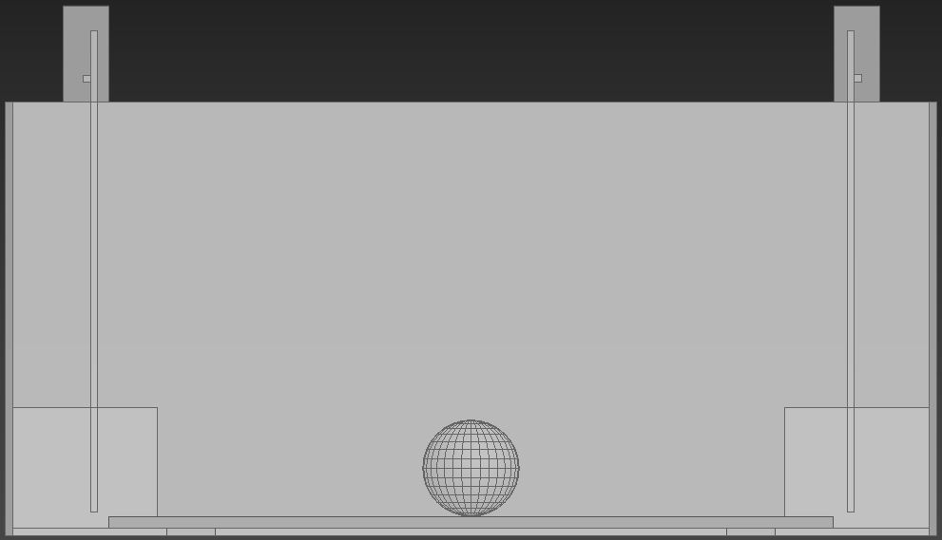

## Side View

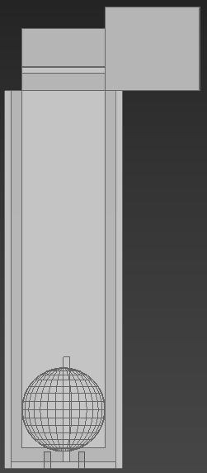

## Top View

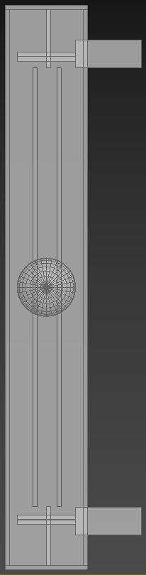

## Angle View

